Name : Dev Adnani  
SID : 202212012

Subject : Systems Programming

Assignment : 2

Q1 : Write a shell script StudentID_Lab2_1.sh which will take up to 9 (i.e. 1 to 9)

command line arguments as integer values and sum them up.

202212012_Lab2_1.sh

#!bin/bash

sum=0

if [ $# -lt 1 ] || [ $# -gt 9 ]

then

echo "Enter arguments between 1 to 9"

else

for var in $@

do

sum=`expr $sum + $var`

done

echo "Sum : "$sum

fi

Run File :

sh 202212012_Lab2_1.sh

Output :

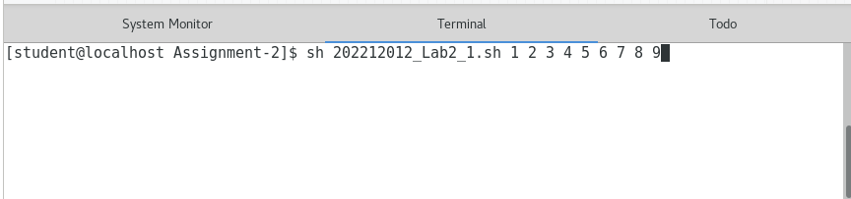

Q2. Write a shell script StudentID_Lab2_2.sh that will take a directory path (e.g. /usr

as input and counts all the files in subdirectories (recursively) Hint: Use ls –R for

listing and wc for counting

202212012_Lab2_2.sh

echo "Enter the directory Path:-"

read path

if [ -d $path ]

then

echo

temp=`ls -R $path | grep "\." | wc -l`

echo

echo "Total $temp"

else

echo "Invalid directory"

fi

Screenshot:

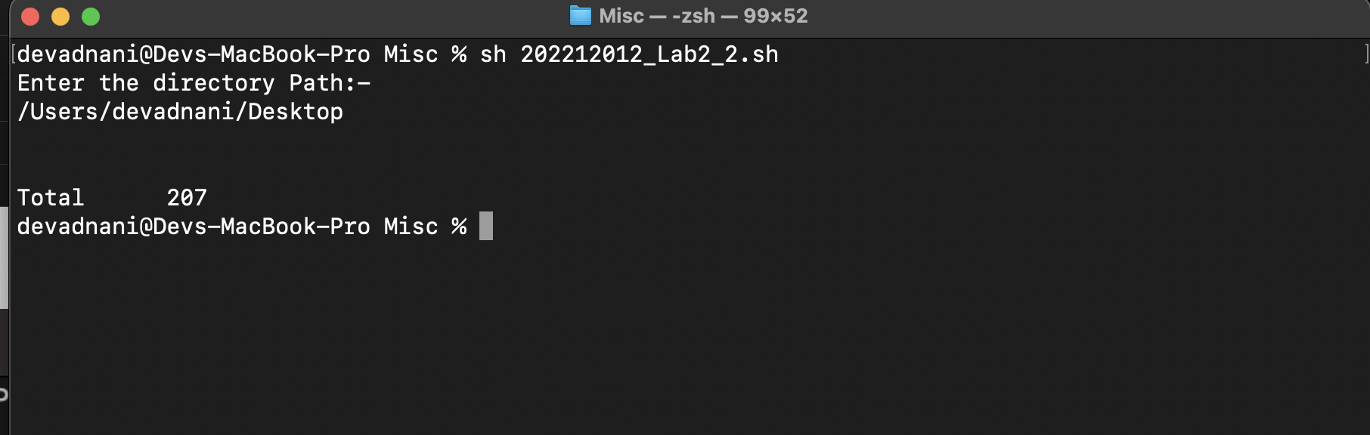

Q3. Write a shell script StudentID_Lab2_3.sh that will take directory path as input

and deletes all the empty subdirectories

202212012_Lab2_3.sh

echo "Enter the directory"

read path

find $path -empty -type d -delete

echo "Subdirectory file is Deleted...."

Screenshot :

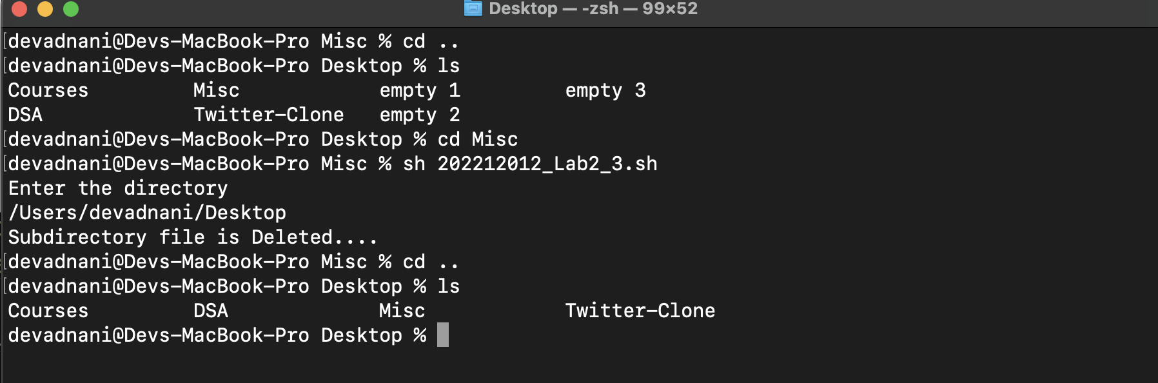

Q4. Write a shell script StudentID_Lab2_4.sh that will take text file as input and

creates a new file by removing all the duplicate lines (or identical lines). Assume

that the input file is not sorted. Use at least one function in your implementation

202212012_Lab2_4.sh

if [ $# -ne 2 ]

then

echo "Enter file which contains duplicate data and new created file"

else

if [ -e $1 ]

then

if [ -e $2 ]

then

echo "$2 Before created"

else

sort -fu $1 > $2

echo "Remove all copy data from $1 to in the $2 "

fi

else

echo "Enter for exist from process"

fi

fi

Screenshot :

